**International Conference on African Large River Basins Hydrology**

**Tracing groundwater salinization processes in an inland aquifer: a hydrogeochemical and isotopic approach in Sminja aquifer, Northeast of Tunisia**

**Sabrine Mejri*3, Anis Chekirbane1, Maki Tsujimura2, Ammar Mlayah1 et Mabrouk Boughdiri3**

1 Laboratoire de Géo-ressources, Centre de Recherches et des Technologies des Eaux de Borj Cédria, BP 273, Soliman, Tunisie

2 Faculty of Life and Environmental Sciences, Université de Tsukuba, Japon

3 Département des Sciences de la Terre, Faculté des Sciences de Bizerte, Tunisie

*Email : [msabrine55@yahoo.com](mailto:msabrine55@yahoo.com)

**ABSTRACT**

Groundwater and surface water of the plain of Sminja (northeastern of Tunisia) are largely influenced by salinization. In some parts of the aquifer, salinity reaches 12 g/L. In order to delineate the saline water plumes, understand the processes and mechanisms that control the evolution of this phenomenon, geochemical data were used to characterize and classify the water samples based on a variety of ion plots and diagrams. Stable isotopes are useful tools to understand recharge processes and to differentiate between different salinity origins. Thus, the salinized parts of the aquifer were delineated basing on the results of a geophysical survey (78 vertical electrical soundings). Indeed, the evolution of the groundwater salinization according to the main flow direction is principally caused by natural phenomenon represented by dissolution / precipitation of minerals dispersed in the saline reservoir formation (Trias) and ion exchange between different ions (rock-water interaction). Furthermore, anthropogenic phenomenon represented by the return-flow of irrigation water and the use of nitrogen fertilizers were identified as non negligible contamination sources in the northeastern part of the aquifer near the irrigated perimeters.

**Keywords**: groundwater, salinization, rock-water interaction, irrigation return-flow, Sminja aquifer

**INTRODUCTION**

Nowadays, in arid and semi-arid region, salinization is identified as an environmental hazard affecting groundwater and surface water resources and is characterized, in some cases, by its irreversible state (Kosmas et al., 2006). Groundwater salinization can be the joint result from point sources such as salts in the parent aquifer material, recharge from salt water intrusion, and saline water flows from adjacent or underlying aquifers (Intisar et al. 2014), or non-point sources such as pesticides, nitrates and irrigation return flows (Cardona et al. 2004), that is mostly the result of agricultural activities. The phenomenon of groundwater salinization is studied and investigated by several authors especially in coastal areas (Chekirbane et al. 2013, Kouzana et al, 2009, Pablo 2004, Kim et al. 2003, Fakhir et al. 2001). However, in inland areas it is rarely considered. Also, most of these studies suggest that salinization of groundwater have been caused by natural processes rather than anthropogenic factors such as agricultural activities or irrigation return flow, whereas, this type of pollution is considered to be the major contributor to water contamination worldwide (Duda, 1993). Sminja plain is located in North East of Tunisia in the upstream part of Wadi Miliane watershed where groundwater quality is deteriorated. Although, in this zone, no comprehensive study of the hydrogeological framework and groundwater resources was carried. The objectives of this study are to clarify the origins of groundwater salinization of Sminja aquifer as well as understanding the mechanisms which control its evolution using geophysical methods and geochemical and isotopic tracers.

**Contribution of geo-electric soundings**

In order to better understanding the hydrogeological behavior of subsurface formations and delineate different areas affected by salinization, we took over some geophysical surveys carried out in the plain of Sminja and reinterpreted the results obtained based on all data provided by the different surface wells and boreholes recently executed. Geophysical study is based on 78 vertical electrical sounding performed by Rejeb, 1982.The apparent resistivity map (Fig. 1) with wavelength AB = 400m and a depth of investigation of 100 m, has allowed to identify four main areas: the first area situated in the North - West, with resistivity between 10 and 20 Ω.m, characterized by outcrops of Oligocene sandstones of Jebel Jahfa. This area is considered as an interesting hydrogeological potential. A second area more interesting located further south - east where consist of a sandy clay aquifer with a resistivity between 10 to 30 Ω.m. The third and the fourth areas located in the North and the North – East, are considered as not interesting hydrogeological potential because of the high salinity and the lithology of the geological formation which is basically clay.

**Water types**

A field survey was conducted in the study area during which surface water (river and dam) and groundwater (deep and shallow aquifers) were sampled in different locations of the plain. A preliminary characterization was carried out using the piper triangular diagram (Piper, 1944). This diagram was used in order to define the different water types and the classification of samples into groups, the analysis of diagrams of anions and cations was a way to estimate geochemical processes in the aquifer (Hounslow, 1995). The chemical compositions of the analyzed water samples are plotted on the Piper trilinear equivalence diagrams shown in Fig. 2. According to this diagram, three main groups of water samples could be identified on the basis of major concentrations, including facies 1: Ca–Mg–HCO3, weakly mineralized and predominant water type in the carbonate-rock aquifers because calcite and dolomite are abundant in these aquifers, located in the recharge areas (piedmont of djebel Zaghouan and Djahfa); facies 2: Ca–Mg–SO4-NO3 reflects the influence of land use activities (excess of NO3) on groundwater mineralization, located in the center and the downstream parts of the plain (irrigated areas), and facies 3: Na–Cl type, generally located in the south-west (El Fahs city), in the north-west (Djebel Aziz) and in the north-east near wadi El Melah. Indeed, a clear migration tendency towards chloride-nitrate pole is observed in the anionic diagram suggesting that return-flow of irrigation water and mixing phenomena as a process to explain the salinity evolution from fresh to saline water. An orientation towards sodium and magnesium poles is recognized for the cationic diagram, which may indicate that cation exchange and dissolution may occur.

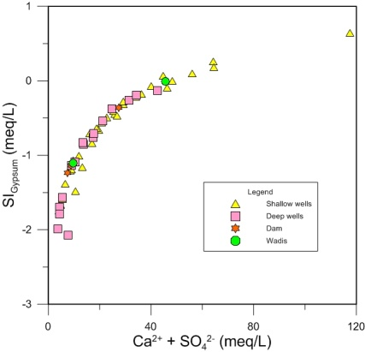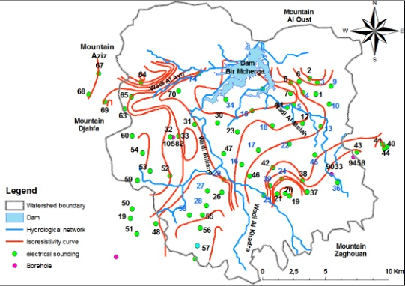

**Figure 1. Iso-resistivity map (**Khanfir, 1988**)**

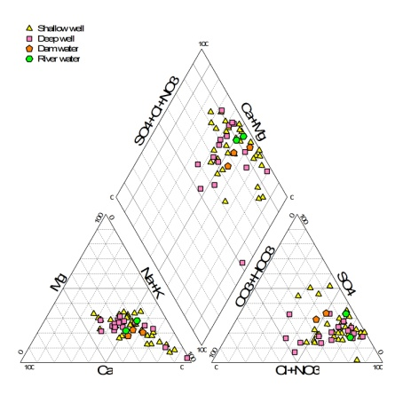





**Figure 2. Piper diagram of water samples in the plain of Sminja**

**Origin of groundwater mineralization in the plain of Sminja**

In order to specify the likely origins of the referred ions and the processes that control their concentrations in the waters of the plain of Sminja, saturation index (SI), which provides information about the minerals that are in contact with groundwater (Post, 2002), was calculated and several bivariate diagrams were completed.

All of water samples have positive values of the calculated SI with respect to calcite, aragonite and dolomite, with exception of two samples (n°9 and n°1119), indicating a saturation state with respect to those mineral phases (Parkhurst et al. 1992), which has a geological origin mainly derived from the abundant limestone outcrops. Thus, calcite is the origin of Ca2+ and HCO3- in these samples and its dissolution was described by Appelo and Postma 2005 (Eq.1):

CaCO3 + CO2 + H2O ↔ Ca2+ + 2HCO3- (Eq.1)

The plot of SIGypsum and SIAnhydrite vs (Ca2++SO42-) displays a parabolic proportional shape evolution with negative values of the saturation indexes, indicating that calcium and sulfate are derived from the same origin, which is the dissolution of gypsum and anhydrite, frequently found in the Quaternary formations (Fig.3).

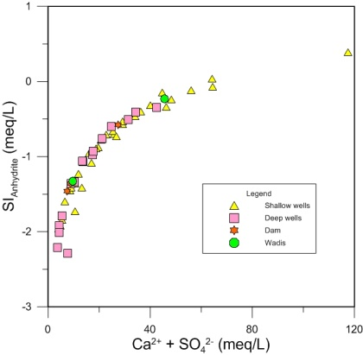

**Figure 3. Plots of (Ca2++SO42-) vs (a) SIGypsum and (b) SIAnhydrite**

The bivariate diagram of sodium vs chloride is used to make distinction between different mechanisms for

acquiring salinity in arid and semi arid regions (Dixion and Chiswell 1992). The relationship between these ions reveals two main groups (Fig.4(a)): the samples of the first group (especially Ca-Mg-Cl-HCO3 type), show a perfect correlation, they cluster along the halite dissolution line, suggesting that sodium and chloride are derived from the same origin which is the dissolution of halite. In the second group, which includes high-salinity samples (Na-Cl type), they do not follow the halite dissolution line, and present depletion in Cl- concentration compared with Na+. Over than geological effects, exists definitely another phenomenon controlling their salinization and this may be the cation exchange reaction which lead to Na+ adsorption on clay minerals and simultaneous release of Ca2+ ions.

A plot of Ca2+ vs SO42- shows that samples of the second group also exhibit a deficit of Ca2+ versus SO42- which is compensated by an excess of Na+ with respect to Cl- (Fig.4(b)), which confirms the Ca-Na cation exchange process.

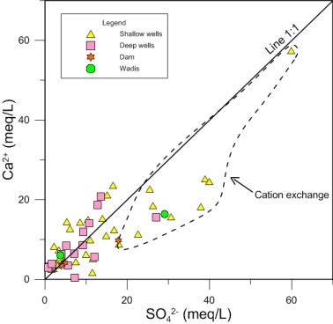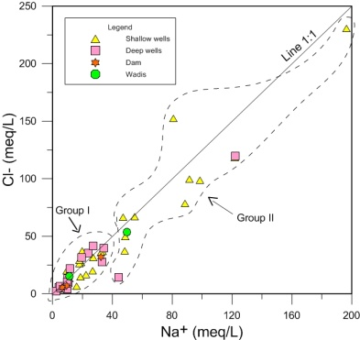

**Figure 4. Plot of Na+ vs Cl- (a) and SO42- vs Ca2+ (b)**

**Nitrate content**

Anthropogenic input can pose a serious threat to surface and groundwater quality, especially in arid and semi-arid areas where high water demands coincides with the dry period. The concentration of NO3- may reflect anthropogenic input into the groundwater chemistry. About 80% of Ca-Mg-SO4-NO3 water type exhibits nitrate values (NO3-) more than 50 mg / l which is the maximum amount in drinking water (WHO 2006).The average value of nitrate in the whole water samples is 117 mg/l. These high nitrate concentrations provide evidence for the significance of the contribution of return flow waters in the unconfined aquifer recharge.

**Isotopic data and salinity origins**

Stable isotopes (δ18O and δD) are important tracers to differentiate water origins. They can be indicators of movement and origin of groundwater recharge as well. Their signatures are compared to those of the precipitation represented by the Global Meteoric Water Line (GMWL) such that: δD = 8 δ18O + 10 (Craig, 1961a), and the Regional Meteoric Water Line (RMWL) which was calculated from the weighed annual mean of precipitation at Tunis-Carthage station (no.6071500), the nearest GNIP (Global Network for Isotopes Precipitations) station. The RMWL follows a linear regression: δ2H = 8 δ18O + 12,4 (Maliki et al.2000, Ben Moussa et al.2010).

The isotopes compositions of δ18O and δ2H of all studied water in the plain of Sminja ranges from -8,79 ‰ à 0,54 ‰ et de -60,22 ‰ à -4,25 ‰ respectively.

The delta diagram of oxygen and hydrogen isotopes plotted in (Fig.5) shows the existing of 3 mains groups: group I, including samples which lie between the RMWL and the GMWL, characterized by more depleted stable isotope values with δ18O of -8,79 ‰ to -5,57 ‰ and δ2H of -60,22 ‰ to -32,05 ‰, suggesting that they originated from infiltration modern precipitation that was not subject to surface or subsurface alteration of its isotopic composition (Grünberger et al. 2004), and non-evaporated water is rapidly infiltrated to the saturated zone. Group II, in which, samples plotted a little below the GMWL belong to Ca-Mg-SO4-NO3 type, indicating water with slight evaporation, this evaporation is probably the result of water-rock interaction and the effect of the irrigation return flow process which is relatively abundant in the zones where flood irrigation is applied in large scale. Group III: contains samples which falls much below the GMWL belonging to Na-Cl type. This deviation is assumed to either the evaporation of meteoric water prior to groundwater recharge, and/or extensive water-rock interaction within the aquifer (Banner et al. 1989).

III

II

I

**Figure 5. Delta diagram (δD vs δ18O**

When the cause of the salinity is due to the concentration of the dissolved salts by evaporation, the regression of deuterium versus oxygen-18 is a typical evaporation process with a slope between 4 and 6 and the correlation between one of these two isotopes and an ionic species such as chlorides will be positive. (Benavente et al., 1990). While in the case where the salinity is due to dissolution of evaporite salts, there is no alteration of the isotopic composition of water percolation and absence of a correlation between the stable isotope and the ionic species. (Fritz & Frape 1990).

A plot of δ18O vs Cl- (Fig. 6) show the existence of three main groups:

1. Samples with Cl- < 20 meq/L and δ18O < -5.75 ‰ they are considered as fresh water recharged from meteoric water.
2. Samples where the isotopic ratios don’t change when the chloride concentration increases and no correlation can be observed between Cl- and δ18O, confirmed that salinization is mainly due to water-rock interactions (ionic exchange reactions, dissolution of evaporitic salts).
3. Samples enriched in δ18O with a slight increase in Cl-, presents a positive correlation between Cl- and δ18O (R² = 0.626). Explain that the origin of salinization is related to the concentration of the dissolved salts by evaporation.

**Figure 6. Chlorinity and stable isotopic composition for the plain of Sminja**

# Conclusion

The present study examined the results of geophysical survey, hydrogeochemical characteristics and isotopic composition of groundwater and surface water in the plain of Sminja, Zaghouan prefecture, semi arid region in northeastern Tunisia. The combination of the results of these tools indicates that water mineralization in the study area is not a homogenous process, but is related to different sources and dynamics with variation in space. Geochemical results show that water sample taken from Sminja plain are divided into Ca-Mg-HCO3, Ca-Cl-SO4-NO3 and Na-Cl types, suggesting that groundwater mineralization is mainly controlled by water-rock interactions represented by the dissolution of evaporate, dedolomitization, and cation-exchange. Nevertheless, anthropogenic processes related to agricultural practices also play an important role in the salinization evolution. Stable isotope signatures confirmed the existence of non-evaporated waters, related to direct infiltration of meteoric water, and evaporated water, assumed to water-rock interaction and return flow of irrigation water. The results of this study make clear that water of the plain of Sminja are contaminated, so monitoring is important for understanding salinity increase. Furthermore, understanding the environmental consequences of agricultural practices is essential to minimize unexpected problems and ensuring the sustainable use of water resources of the region.

# REFERENCES

1. Appelo C.A.J. and Postma D. (2005) - Géochemistry, Groundwater and pollution. 2nd eds. Amesterdam, the Nertherlands: A.A.Balkema Publishers.
2. Banner, J.L., et al., 1989. Isotopic and trace-element constraints on the origin and evolution of saline groundwaters from central Missouri. Geochimica et Cosmochimica Acta, 53, 383-398. doi : 10.1016/0016-7037(89)90390-6.
3. Ben Moussa, A., et al., 2010. Hydrochimical and isotopic investigation of the groundwater composition of an alluvial aquifer, Cap Bon Peninsula, Tunisia. Carbonates Evaporates, 25 (3), 11.161-176.
4. Cardona, A., Carrillo-Rivera, J., Huizar-Alvarez, R. and Garniel-Castro, E., 2004. Salinization in coastal aquifers of arid zones: an example from Santo Domingo, Baja California Sur, Mexico.Environmental Geology, 45: 350-366.
5. Chekirbane, A., Tsujimura, M., Kawchi, A., Isoda, H., Tarhouni, J., Benalaya, A., 2013. Hydrgeochemistry and groundwater salinization in an ephemeral coastal flood plain: Cap Bon, Tunisia. Hydrological Sciences Journal, 58 (5), 1097 – 1110.
6. Craig, H., 1961. Isotopic variations in meteoric waters. Science, 133, 1702-1703.
7. Dixon, W. and Chiswell, B., 1992. The use of hydrochemical sections to identify recharge areas and saline intrusions in alluvial aquifers, southeast Queensland, Australia. Journal of Hydrology, 130, 299-338.
8. Duda, A.M., 1993. Addressing non-point sources of water pollution must become a national priority. Water Science and Technology 28, 1-11.
9. Fakir, Y., et al., 2001. Exploitation et salinité des aquifères de Chaouia côtière, littoral atlantique, Maroc. Journal of African Earth Science, 32, 791–801.
10. Grünberger, O., Montoroi, J.P., and nasri, S., 2004. Quantification of water exchange between a hill reservoir and groundwater using hydrological and isotopic modeling (El Gouazine, Tunisia).Comptes rendus Geoscience, 336, 1453-1462. doi: 10.1016/j. erte.2004.08.006.
11. Khanfir R. (1988) – Etude des eaux souterraines de la plaine de Sminja. Rapport D.G.R.E.
12. Kim et al., 2003. Hydrogeochemical characterization of major factors affecting the quality of shallow groundwater in the coastal area at Kimje in South Korea.
13. Kouzana, L., Ben Mammou, A., and Sfar Felfoul, M., 2009. Seawater intrusion and associated processes: case of the Korba aquifer (Cap-Bon, Tunisia). Comptes Rendus Geosciences, 341 (1), 21-35.
14. Kosmas, C., Tsara, M., Moustakas, N., Kosma, D. and Yassoglou, N., 2006. Envirnomentally sensitive areas and indicators of desertification In: W. Kepner, G., J.L. Rubio, A. David and M. Pedrazzini (Editors), NATO Security through Science Series. Desertification in the Mediterranean Regio. A Security Issue, PP. 527-547.
15. Maliki, M.A., et al., 2000. Relation entre nappe superficielle et aquifère profonde dans le bassin de Sfax, Tunisie. Comptes rendus de l’Academie des Sciences, 331 (1), 1-6.
16. Pablo, P., 2004. Seawater intrusion and associated processes in a small coastal complex aquifer (Castell de Ferro, Spain).
17. Parkhurst DL, Christenson S, Breit GN (1992) Groundwater-quality assessment of the central Oklahoma

aquifer, Oklahoma: geochemical and geohydrologic investigations. US Geol Surv Open File Rep, 92-642.

1. Piper, A.M., 1944. A graphic procedure in the geochemical interpretation of water analyses. EOS Trans.Am. Geophys. Union 25, 914-923.
2. Post V.E.A. (2002) - Chemistry for modellers aqueous geochimistry in coastal area. 17 th salt water intrusion meeting, delft, the Nether Lands; 6 - 10 May. 3-12.